Evidence Output

T001:

Valid modulus number.

Input number 135275.

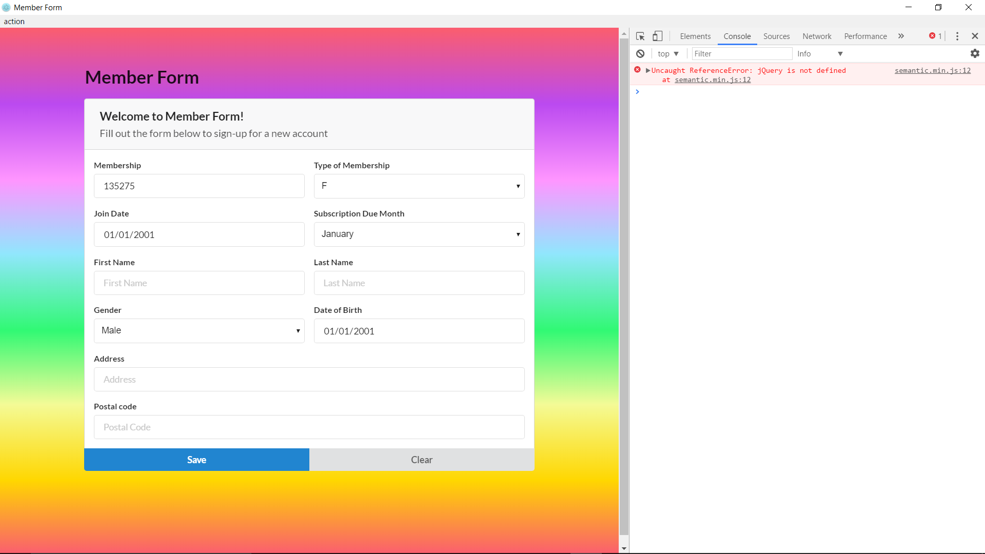

Membership number case valid success.

